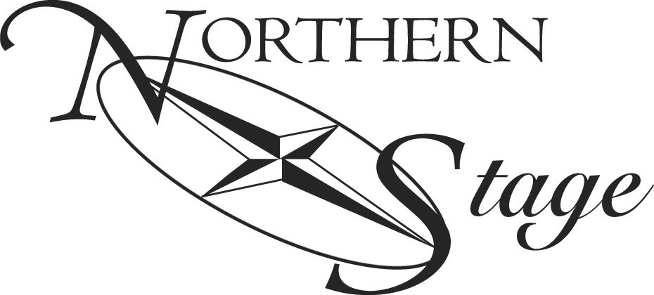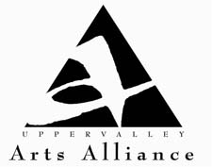

A Call to Action: Let’s Do Something Together
Meeting Notes – January 30, 2013

Here are some notes on each of the issues discussed:

- Create a significant marketing opportunity
  - Voting results: 1st. 2
2nd 8
3rd 13
  - Although this was not a hot topic, the following ideas were put on the table:
    - Free Website design. Libby Moyer suggested looking at drop and drag website building. Go to: www.weebly.com
    - Broadband continues to be the biggest problem in the UV delaying and deterring significant website work
    - Another free web location for videos and photos: www.wix.com
    - Consider cross pollinating
    - Use Constant Contact to email newsletters with what’s going on and by building a database of new readers
    - Other blog resources: Wordpress, Blogger

- Start a conversation – new business partner
- Voting results: 1st 3
2nd 13
3rd 8
- Some ideas to consider:
- Vodka tasting.
- Contact new businesses in your local area. They could be very interested in a win-win collaborative.

- Explore ways to reach new audiences
- Voting results: 1st 19
2nd 2
3rd 3
- Here are some options:
- ListServ
- Constant Contact
- Posters (print mailing)
- Tweets (i.e., Cyber Monday posting Northern Stage tix for Peter Pan)
- Facebook pages
- R. C. Brayshaw (have workshops on marketing)
- Corrections Institutions/Concord (have printing at very reasonable costs. Don’t try to get anything done in August because of school needs)
- Valley News (meet Rick Wallace)

Russ Maitland Presentation
The focus of Russ’ PowerPoint was on the subject of collaboration. Highlights included:
- In economically difficult times, he has seen success where 501c-3s partner:
- mailings
- printing
- advertising
- grant applications
- bartering services instead of using cash

- To set up a partnership, all parties need to share:
- MOU – Memo of Understanding – which covers
  - stated outcomes
  - role responsibilities
  - resource allocation
  - when/how to cancel
  - risk/liability limits
- Flexible mindset accepting mistakes will be made & plans may change
- Ongoing face-to-face communication
- Multiple forms of communication
- Who covers to protect your 501 status: Legal counsel, insurance covers

- Collaboration stages:
- Inspiration
- Formalization
- Actualization
- Benefits
  - tell story/exposure
  - inspire community support & awareness
  - broaden donor base

General discussion and new ideas:
- 80,000 people in the Upper Valley
- Tuck School at Dartmouth is willing to send students to do workshops and research
- Weeblie & U-stream good free web use
- Networking outside your organization: Rotary, Chambers, Town meetings
- NH Arts Learning Network www.nhartslearningnetwork.org
- Creative Communities Network. This organization was listed on the Art Connections page distributed at the meeting. A website is to go online shortly. For further information contact Joanne Wise.

Next steps:
- Establish monthly gathering of Arts Alliance mixers. Linda Copp and Sheila Moran will co-host the first gathering at the Lebanon Ballet School. Details to follow.
- Visit the Upper Valley Arts Alliance to:
- Add your organization’s events to the calendar www.uvarts.org
- Start a conversation via the “Exchange”
- Keep the Alliance alive with a donation. Go to Donate on the website for details.

